InCoB 2006
International Conference on Bioinformatics-2006
New Delhi, India

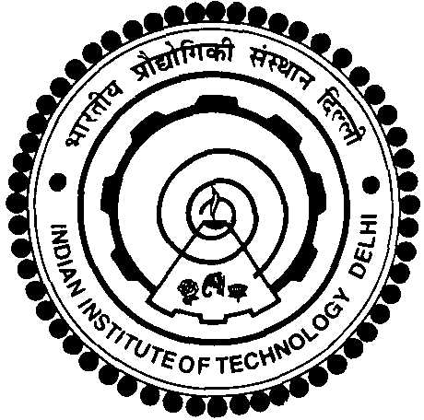



www.scfbio-iitd.res.in
www.jnu.ac.in/
http://dbtindia.nic.in/

InCoB 2006 is the fifth annual international conference of the Asia Pacific Bioinformatics Network (APBioNet) to be held from 13th -15th November, 2006 in New Delhi, India.

Previous International Conferences on Bioinformatics (InCoB) were held in
- InCoB 2002 at Bangkok, Thailand,
- InCoB 2003 at Penang, Malaysia,
- InCoB 2004 at Auckland, New Zealand
- InCoB 2005 at Busan, South Korea

This conference brings together scientists from different branches of biology, medicine, computer science, engineering, mathematics and statistics. The scope of InCoB encompasses the development and application of computational methods for solving biological problems at different levels of biological organization. InCoB 2006 hopes to provide a common platform for both academia and Industry to come together to enrich themselves with current developments and future trends in the field of computation biology and for developing products and services useful to society.

The conference will feature original, refereed papers, which will be published in the conference proceedings. There will also be tutorials, posters, software demonstrations, and an exhibition of hardware and software vendors.

Indian Institute of Technology Delhi, Jawaharlal Nehru University Delhi, and the Department of Biotechnolgy Govt. of India are the organizers of the event.

Abstract
Abstracts of full papers and poster presentations, exhibits etc. are invited from students/researchers/Industry.

Abstract Submission: 31st Aug, 2006
Acceptance of Abstracts: 30th Sep, 2006

Registration fee

 |  | Upto 15 October, 2006 | After 15 October, 2006
1 | Foreign Academic | US$ 300 | US$ 400
2 | Foreign Students | US$ 150 | US$ 200
3 | Profit Institutions | US$ 500 | US$ 700
4 | Indian Academics | Rs 3000 | Rs 4000
5 | Indian Students | Rs 1500 | Rs 2000
6 | Indian Corporate | Rs 5000 | Rs 7500

The registration fee is to be remitted as Cheque or Demand Draft in the name of “Registrar, IIT Delhi.(InCoB-2006)” and to be mailed to
Dr. S. K. Khare, Department of Chemistry, Indian Institute of Technology, Hauz Khas, New Delhi-110016.

Dates: November 13th to 15th, 2006.

Venue: Hotel Ashoka, Diplomatic Enclave, 50-B, Chankyapuri,, New Delhi-110021

Address for Correspondence

Dr. T. Madhan Mohan, Director, Department of Biotechnology, CGO Complex, Lodhi Road, New Delhi
Email: madhan@dbt.nic.in; http://www.dbt.nic.in

Prof. Alok Bhattacharya, School of Life Sciences, Jawaharlal Nehru University, New Delhi -110067, India
Email: alok0200@mail.jnu.ac.in; http://www.jnu.ac.in

Prof. B. Jayaram, Professor of Chemistry & Coordinator, Supercomputing Facility for Bioinformatics & Computational Biology, IIT Delhi, Hauz Khas, New Delhi 110016. India.
Email : bjayaram@chemistry.iitd.ac.in; http://www.scfbio-iitd.res.in

Event Manager: Neumech Events, 51 Mandakini Enclave, New Delhi-110019
neumech@nda.vsnl.net.in www.conferenceindia.org

Website of Information: www.incob2006.in
About Delhi
Delhi, the capital of India, sprawled over the west bank of the river Yamuna. Historically, the city has long since been the foremost in political importance with successive dynasties choosing it as their seat of power, between the 13th and the 17th centuries. Remnants of the glorious past survive as important monuments in different parts of the city.

Early November is the best time to visit Delhi when the nights are cool and the days filled with mellow sunshine. The max temperature during the conference will be about 28º C and min 15º C.

